**PCS TEST: Automation Overview**

**API and GUI**

1. **Packages:**

Following packages are used

* **Pcs.api:** This package contains all API test classes
* **Api_Param:** API test suite
* **Pcs.core:** This contains all core function for the framework
* **CommonFunction: All browser methods**
* **PCS_DataProviders:** Test data feeder through data providers.
* **Pcs.pom.gu**
* **Login_POM :** This class has all page objects and methods for login
* **Pcs.pom.testsuites**
* **Login_TestSuite:** This is test suite class where all test annotated methods are defined and extent report objects are initialized. This is the file which has actual tests.

1. **Folders:**

* **Testng_testsuite.xml:** This folder contains testng.xml for test configuration
* **Jars:** All third party dependency jars are kept inside it.
* **Reports:** All report gets stored with time stamping here
* **Logs:** It stores all logs as per logging made while test case writing.
* **Test-ouput:** Contains default testng test output.
* **Classes:** Compiled classes

1. **Files:**

* **Testng.xml:** This file is inside the folder Testng_testsuite.xml and this contains package declaration and test configuration declaration, and some parameters like browser and URL which can be configured.
* **Build.xml:** For test execution in Jenkins, running test from command line and report generation
* **Extent-config-logs.xml:** For generating extent log
* **Extent-config.xml:** For generating entire HTML report

**Running the test:**

* **Prerequisites:**
* Java must be installed
* Eclipse with testng and ant should be configured on system.
* **Running The test via eclipse using testng.xml:**
* Extract the project at some location in your system and import into eclipse.
* Now goto testng_testsuite.xml file-testng.xml-> right click **and run as testngSuite.** Following type of result will be show in testng Result pane in eclipse with all test data iterations as show below.

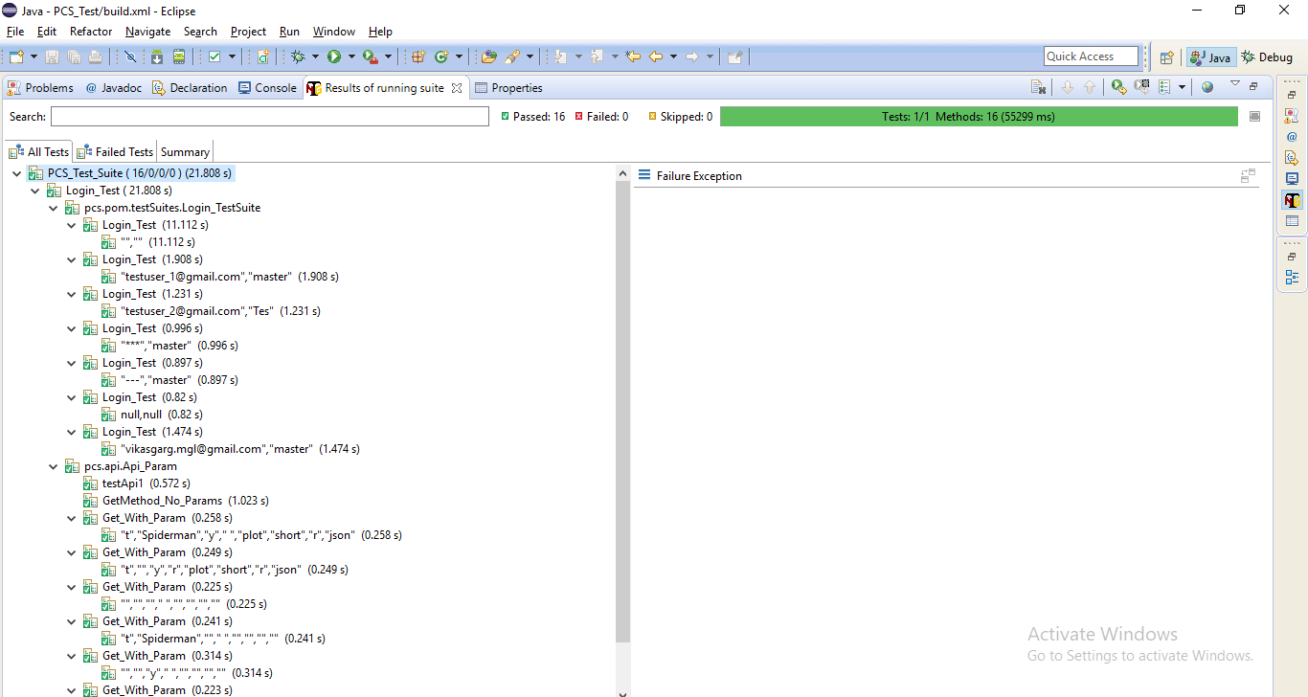

* **Running The test via ant:**
* Extract the project at some location in your system.
* Now goto command prompt and go to project directory
* Now type ant as shown below on the command prompt(provided ant is configured properly)

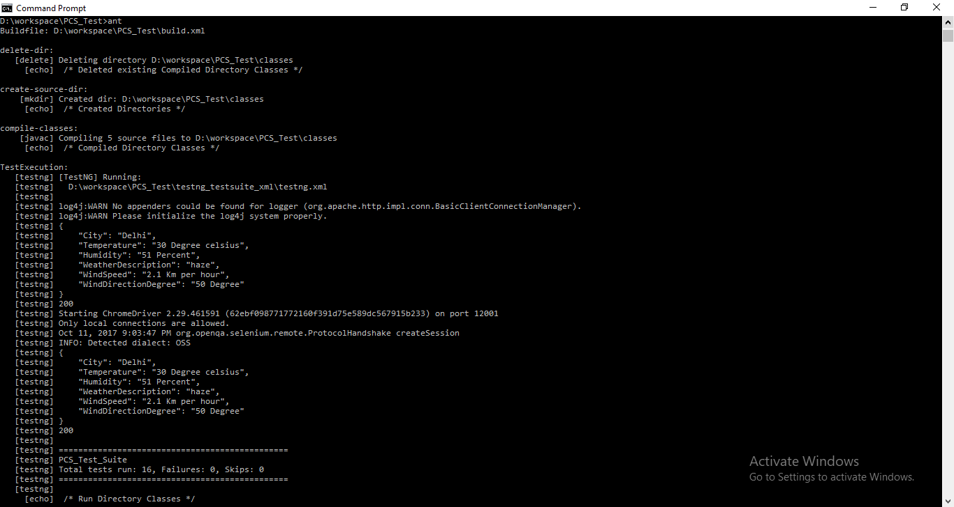

**Extent Report: Enhanced HTML Reporting**

* **API_Test: Report**
* **GUI_Test:Report**
* **API_Test:Log**
* **GUI_Test:Log**

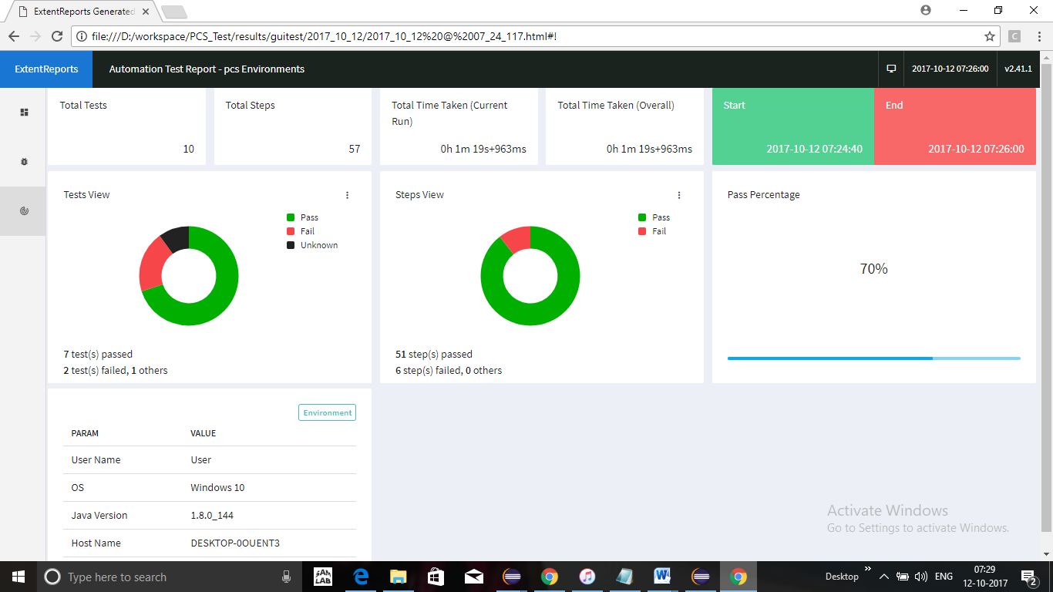

**Logs**

